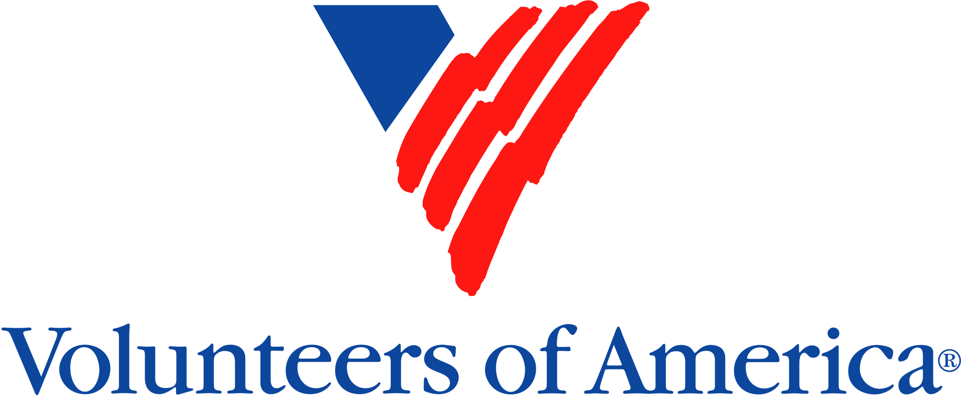

Mission Statement

Volunteers of America is a movement organized to reach and uplift all people and bring them to the knowledge and active service of God.
Volunteers of America, illustrating the presence of God through all that we do, serves people and communities in need and creates opportunities for people to experience the joy of serving others.
Volunteers of America measures its success in positive change in the lives of individuals and communities we serve.

Our Vision for the Future

Building on our healthcare and housing, successes and working with Volunteers of America affiliates,
We will be a leader in creating innovative, compassionate and comprehensive responses to human needs.

Values Statement

We Value Respect

We have trust in and respect for individuals. We believe that people want to do a good job and will do so, given the proper tools and support.
We respect the independence and intrinsic worth of the individuals that we serve.

We Value Teamwork
We recognize teamwork as essential to the success of our organization.
We believe that use of collective knowledge, experience and abilities increases the opportunity to reach our fullest potential.
We communicate and share information in a constructive, open and supportive manner.

We Value Honesty
We are committed to uncompromised honesty in all of our actions.

We Value Diversity
We believe that our organization benefits from the valued differences in people.
We value an inclusive environment, which supports the diversity of our customers.
We make efforts to adapt services to the cultural differences, personal preferences and beliefs of our customers

We Value Responsibility
We are committed to acting in accordance with the Volunteers of America Code of Ethics.
We recognize the importance of participating in planning for changes, and seek opportunities to become involved in making improvements.
We accept personal responsibility for our actions, and for obtaining information that is required for us to do “the right thing” in the name of excellent service to our customers.

We Value Quality

Our business is to please our customers. Our care and services should exceed their expectations.
We welcome ideas and suggestions from satisfaction surveys and incorporate them into service delivery.
We strive for innovative and creative solutions.

